**Muhammad Abdullah**

**SE(4A) | 19F-0916**

Database Lab

Integretion of sql database with windows form c#

**WELCOME PAGE**

**MAIN PAGE**

**Submit Record (Entering Values)**

**Submit Record (Clicking Submit Records)**

**Submit Record (Showing Values by Select Records)**

**Delete Record (Showing Values to Delete)**

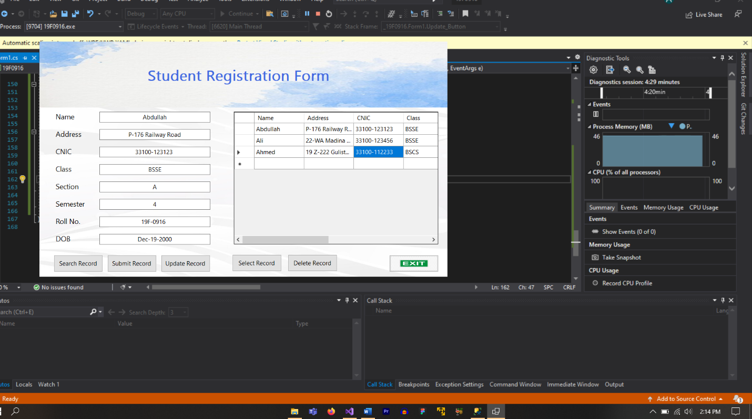

**Delete Record (Deleting Records by Delete Records)**

**Delete Record (Showing Records After Delete Records)**

**Update Record (Update Records by Update Records)**

**Update Record (Updating Ali’s Section B to A)**

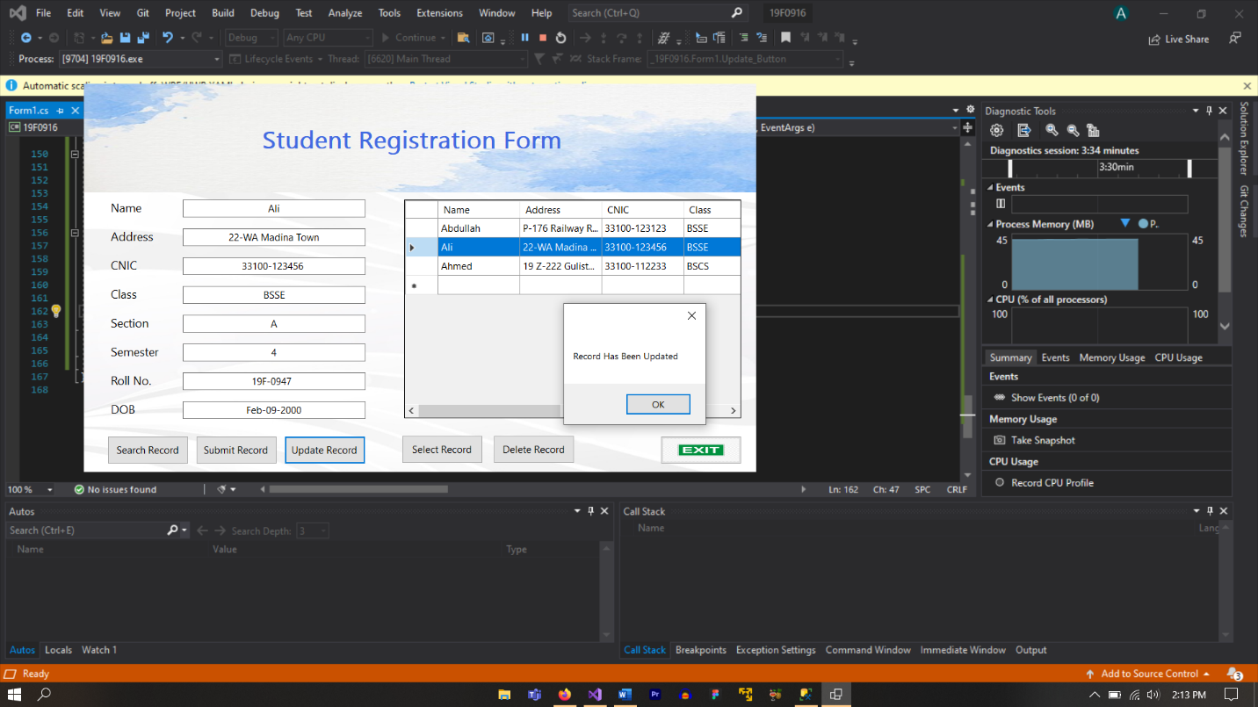

**Searching Record (Searching Records by Search Records)**

**Searching Record (Entering Roll No to Search)**

**Searching Record (Clicking Search to Search)**

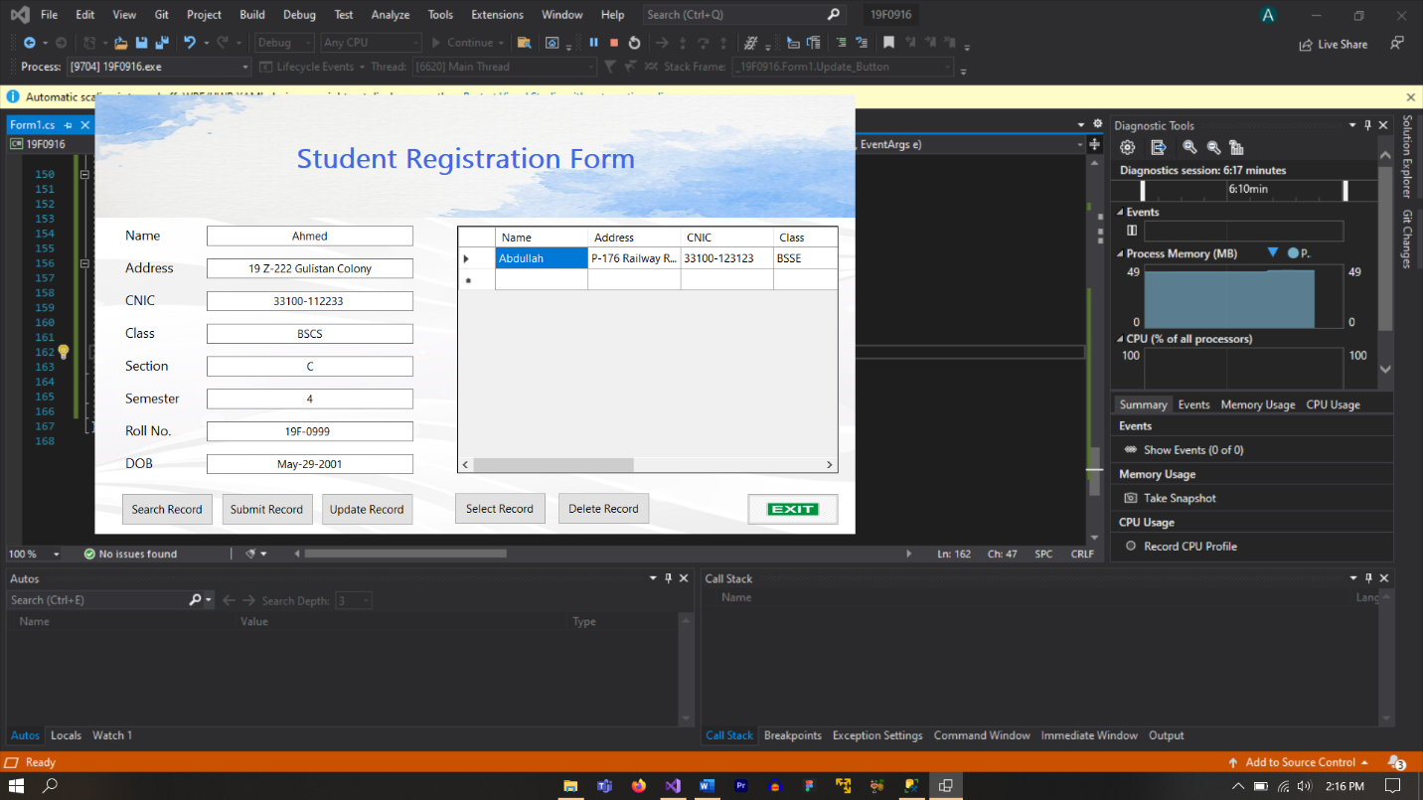

**Exiting from System**

**SQL Database from MS SQL at the end**

**PS: Project File is attached for Windows Form and SQL database File is also attached with it. If screenshots are not visible, please use ScreenShots folder provided in zip file**

**Thank You!**